Navigating Through the Posters

By

Ed Christopher
Chair, Committee on
Urban Data and Information Systems

FHWA Resource Center
19900 Governors Drive
Olympia Fields, Illinois 60461

708-283-3501 (fax)
708-574-8131 (cell)
708-283-3534 (voice)
edc@edthefed.com

May 11.2005
As part of the conference, a call for posters was issued. Posters were sought for applications of Census 2000, CTPP2000, or the American Community Survey (ACS) data. Topics sought included, descriptive analysis and reporting (trend analysis), travel model calibration, travel model validation, survey weighting and adjustment, public Involvement, special studies (environmental justice, transit service planning, homeland security, emergency preparedness planning, bike and pedestrian) and micro-simulation.
In preparing posters, authors were asked to explicitly address the following questions. What census data was used? How was it used? What value was achieved? And, what problems/issues were encountered? Travel support was provided.

Selection Process

A total of 30 abstracts were submitted of which 20 were selected. This cut off was established due to display space limitations as opposed to quality restrictions on the posters. The abstract review and selection process was somewhat straightforward. A review committee of 4 members from the conference organizing committee was assembled and each reviewer was asked to judge the abstracts against the goals of the conference and the contents of the poster call. Each reviewer was then asked to assign a rating of 1 to 5 (with 5 being high) to each abstract. The ratings of each reviewer were then added together and an initial ranking produced. The committee then met, discussed the rankings and identified 20 posters for acceptance with two alternatives identified as backups. Prior to the meeting but after the abstracts were ranked one author withdrew their abstract with another abstract being withdrawn after selection. Exhibit 1 shows the initial rankings by each committee member with the selected posters shown in bolded text. In short the process followed a dual approach of a ranked scoring process followed by a committee review to assure that any potential reviewer bias did not adversely affect the outcome.

The Final 20

A total of twenty posters were moved forward and displayed at the conference. In terms of overall statistics all the posters focused on census data but that is about where the generalities stopped. Of the 20 posters 7 focused exclusively on CTPP data, 3 on the Summary File (SF) data, 1 on LEHD and another on a geographical analysis which could be applied to any census data set. The remaining 8 posters focused on a combination of Census products including CTPP, SFs, PUMS, ACS, and the CTPP-like tabulation of the ACS data known as the NCHRP 8-48 data set.

Exhibit 2 contains a listing of the 20 posters, their authors and a brief abstract. The posters are listed in no particular sort order other than the original identification number assigned to them by TRB for internal tracking and organization.

Exhibit 2: Posters Presented at the Conference
04 | Comparison of 2000 JTW Census Data, Gravity Model Results, and SMARTRAQ Household Travel Survey Data, in the Trip Distribution Model at the ARC  Laura Chen and Guy Rousseau, Atlanta Regional Commission | In this poster the Atlanta region 2001-2002 household travel survey Origin-destination (O-D) pairs, and the 2000 Census Journey-to-Work O-D data are compared. This was done as final check of the ability of the calibrated Atlanta home-based work gravity model to replicate observed travel patterns. The review showed that the calibrated gravity model generally provides reasonable estimates of the home based work trips for individual counties. There are some counties where the gravity model appears to underestimate the intra-county trips as compared to the CTPP flows. In these areas the author notes that they are all located on the edge of the regional travel demand model study area where the zones are relatively large.
07 | Evaluation of CTPP 2000 for the Delaware Valley Region  Thabet Zakaria, Delaware Valley Regional Planning Commission | In this poster, the CTPP 2000 data for the Delaware Valley region is reviewed, analyzed, and evaluated. The evaluation of Parts 1 and 2 indicated several errors in the data, which were corrected before the data were used in various transportation planning projects. Data rounding and disclosure rules, applied to some tables in Part 3, made the zone-to-zone worker flow data by means of transportation totally useless. However, CTPP data are generally accurate and useful for transportation planning. Based on the evaluation, a set of eight recommendations regarding sample size, nonresponse and imputation, public relations and marketing, place of work coding, processing, data rounding, swapping, and disclosure threshold are proposed.
09 | How Census 2000 and CTPP 2000 Data Helped Us in the Use of Regional Travel Demand Forecast Model?  Sharon Ju, Houston-Galvaston Area council | This poster shows how 2000 Census population and the CTPP data were used in the Houston Galvaston Area council’s (H-GAC) travel model applications. Before working with the CTPP data two adjustments were made. First CTPP TAZs were reconciled with the H-GAC TAZs. A second adjustment that consisted of allocating the ungeocoded employment in smaller counties to TAZs. Some of the specific CTPP uses that are shown include: modifying travel model input population numbers by implementing a Census 2000 household size factor; drawing from Census population and household information such as population by age, household by size by income, and head of household by age in the travel model calibration process; comparing CTPP workplace totals with current zonal employment; and, converting zonal journey-to-work person trip to vehicle trips to validate the current travel model. Overall the Census and CTPP population and household data was an excellent source of model calibration and development due to its large sample size and consistency between survey years. Furthermore, CTPP 2000 journey-to-work trip flow data by zone provided a good benchmark on how travel forecast model performs.
10 | Using the American Community Survey to Monitor the State of the System  Shimon Israel, Metropolitan Transportation Commission | This poster describes the use of the ACS at the MPO for the San Francisco Bay Area, the Metropolitan Transportation Commission (MTC) in its “State of the System” (SoS) report. MTC’s existing SoS report provides a comprehensive digest of key transportation network and facility performance measures, compiling information from various sources, including data on both perceived and actual conditions of the transportation system. MTC has an interest in expanding the scope of SoS report by monitoring local and regional trends in population, labor, commuting, disability, income, age, and vehicle availability. This poster includes several applications of ACS data for monitoring the trends.
12 | TriMet’s Transportation Investment Plan(TIP): Ensuring Transit Equity with the US Census  Ida Hardin, TriMet | In 2002, TriMet adopted a strategic direction known as the Transportation Investment Plan (TIP). The primary objective of the TriMet TIP is to establish a total transit system by taking a more focused and comprehensive approach to planning and development. TriMet’s concept of a total transit system not only consists of bus routes and light rail, it also includes customer services and amenities and transit equity. The Census data was used to ensure that TriMet’s distribution of services and amenities are fair and equitable throughout the system. This poster details that use.
14 | Size Matters: Using Census Block, Block- Group and Tract polygons in Transit Planning  Jesse Simon, Ph. D., Los Angeles County Metropolitan Transportation Authority | The Census divides urban areas into different sized polygons: Census Tracts, Block- Groups and Blocks, where Block- Groups can be mapped as subsets of Tracts and Blocks as subsets of Block- Groups. In Los Angeles County, Tracts have an average radius of 0.7 miles, which is considered too long for transit walk distances. However, tracts can be used to address global planning issues, such as transit accessibility of rail corridors to lower income communities. Block- groups have an average radius of 0.4 miles, which is between bus and rail walk distances. Block- Groups have been used to evaluate sighting of transit centers. Metro’s Title VI analysis (accessibility by ethnic status) uses tracts but will substitute block- groups when service only touch a single boundary area of a tract. Blocks are generally the size of city blocks. Metro uses them to analyze accessibility for populations with limited mobility, such as wheelchair users. The poster provides illustrations of each type of this analysis.
15 | Comparing Decennial Flow Data to Place of Work Data from the Local Employment Dynamic Program  Wende A. Mix, Ph.D.  Buffalo State College and Philip N. Fulton, Ph.D., Economic Research Services, USDA | In 2003, the Census Bureau conducted a pilot project for the Bureau of Transportation Statistics to determine the feasibility of producing journey-to-work data from the Census Bureau's Local Employment Dynamics (LED) program. The project resulted in several data files containing place of residence, place of work, wage, and industry classification data for the states of Illinois and Florida. Using the LED data for Illinois, this poster presents the results of an initial assessment of the comparability of LED journey-to-work data with data from the decennial census and the ACS. Suggestions are made for next steps in the project and ways to improve the LED products to further enhance their potential utility for transportation planning.
16 | Smart Moves, Utilizing Census Data for Transit Planning  Caitlin Cottrill, Mid-America Regional Council | In this poster metropolitan Kansas City’s vision for expanded and enhanced public transportation services are explored. A key part of the planning process has been the utilization of Census data to determine those areas most appropriate for transit, based upon current and forecast population and employment densities, automobile ownership, and trip patterns. GIS maps provided the opportunity to overlay proposed transit lines on layers of Census data to help determine those areas most suited to flexible service, fixed route, or commuter express service. Journey-to-Work data provided needed information about trip patterns in the region, and allowed for more informed decisions to be made regarding services needed to connect counties to counties. The final plan represents a structure of service based both upon public input regarding perceived needs, as well as from Census data based evaluations.
19 | Getting Around Rounding and Suppression Issues with CTPP  Kristen Rohanna, San Diego Associations of Governments | SANDAG, the MPO for San Diego, wanted to use CTPP data to evaluate the impacts of major transit investments in the region. Ideally, Table 3-06 (Means of Transportation) would have been the source of the needed data. However, the corridor was defined by census tracts and Table 3-06 showed a loss of 36 percent of total workers residing in the region due to rounding and threshold at that summary level. A “back-door” method was used to extract the corridor flow data by dividing data from Table 3-14 (Aggregate travel time by Means of Transportation and Time Leaving Home) by data from Table 3-08 (Mean travel time by Means of Transportation and Time Leaving Home). This method gave a reliable count of workers at the census tract summary level. The mode-split counts were used to create maps and tables for transit investment impact analysis.
24 | Using Census Data to Develop a New Kentucky Statewide Traffic Model  Kenneth Walker, Wilbur Smith Associates and Amy Thomas, Kentucky Transportation Cabinet | Census data in various forms were used as part of the most recent update of the Kentucky Statewide Traffic Model (KYSTM). This poster shows how the census data was used in the development of the KYSTM. The products used ranged from Geography (TAZ-UP/Combined Zones, Census Block Group, and Census Places); CTPP Part 2 and Part 3 data; and the Summary Files. Kentucky was one of the only states to take advantage of the Combined Zone option for tabulating CTPP 2000 data.
25 | A Compendium of 2000 Census Commute Analyses for the Hampton Roads Region  Andy Pickard, Hampton Roads Planning District Commission | A regional summary of the 2000 Census commute data has been prepared for Hampton Roads by the Hampton Roads Planning District Commission, the MPO staff for the region. The predominant products used were CTPP Part 1 (place of residence), and the county-to-county worker flow files. Comparisons between the localities of the region, Virginia, and the U.S. on several measures (income per household, means of transportation to work, travel time to work) were prepared. Flows between localities and into and out of the region were examined, with each locality classified according to its percentage of internal, in-commute, and out-commute trips. Areas with a high portion of workers using unique modes were identified on a series of maps. When packaged together, these analyses provide a broad and informative overview of Census commute data for the Hampton Roads region.
26 | Analysis of Travel Behavior Using the ACS  Joost Gideon Berman, Siim Soot and Susumu Kudo, University of Illinois at Chicago | This poster models and analyzes travel behavior by race/ethnicity in Lake County, Illinois. Lake County, just north of Chicago’s Cook County, is one of the ACS test sites having data available since 1999. The poster presents the demographic and socio-economic profiles and trends in Lake County; analyzes the travel-related characteristics of the growing Hispanic and stable non-Hispanic African American populations of Lake County; and, examines strengths and weaknesses of the readily available ACS products for transportation analysis. The main census data products used were the ACS Summary Tables (1999-2003) and CTTP test ACS (1999-2001) for Lake County. Analysis is on the county level for the ACS summary tables and on the TAZ level for the CTTP ACS test data.
28 | Florida Journey to Work GIS Web-Site  Martin Catala, University of South Florida | To present transportation related information to the public, decision makers, and the planning community, an on-line customized application was created for the state of Florida. The application uses data from CTPP Part 1, Part 2, and Part 3 and a summary level that focuses on Census Designated Place’s (CDP). A GIS based mapping function is incorporated into the application to show the commute flows from Part 3. The website is interactive and designed to make the CTPP data understandable to all. This poster highlights and shows the various web page screens.
30 | Using Census Data to Examine the Pedestrian Friendliness of the Built Environment  Hannah Young and Daniel Rodriquez, University of North Carolina Chapel Hill | Transportation and land use planners have a growing interest in understanding the attributes of the environment that can support walking activity. This poster highlights the development of a “Built Environment Index (BEI), which summarizes attributes of the built environment believed to support non-motorized transportation activity. The BEI is a desktop application and utilizes three measurement domains (development intensity, motorized transportation, and pedestrian/ bicycle infrastructure). It relies upon a non-hierarchical cluster analysis using a k-means methodology to classify the data into categories of pedestrian friendliness.
31 | Environmental Justice for Long-Range Regional Transportation Plans: Using Census Data to Target Communities of Concern  Rachel Gossen  Metropolitan Transportation Commission | As the MPO for the San Francisco Bay Area, the Metropolitan Transportation Commission (MTC) is charged with measuring the distributional effects of the transportation investments outlined in the region’s long-range transportation plan. One analysis MTC performs is to assess whether minority and low-income populations are disproportionately burdened by the planned transportation investments. MTC used three Census data sets to perform this analysis: Summary File 3 (SF3), the 5-percent Public Use Microdata Sample (PUMS), and CTPP 2000. SF3 and PUMS were used to identify high concentrations of minority and low-income residents. Additionally, these data were used to stratify residents by vehicle availability and means of transportation to work. Jobs held by low-income individuals were extracted from the CTPP 2000 Part 2 and used to explore the relationship between jobs and housing for low-income residents. Once these communities were defined, indicator variables associated with access and travel time to jobs and essential destinations, user benefits, vehicle miles traveled, and emissions were extracted from MTC’s travel forecasting system. A comparison was then made between communities of concern and the remainder of the region. This poster highlights the analysis.
33 | Enhanced Inputs for Travel Demand Modeling: Using Census Data with Land Cover Data  Saket Sarraf, Varkki George Pallathucheril, Zhanli Sun and Brian Deal, University of Illinois at Urbana Champaign | Travel demand models require various demographic and economic variables at the Traffic Analysis Zones (TAZs) level. These values are derived from Census data in one of two ways. In one approach, TAZs can be drawn to closely match Census boundaries. Then the value the variable takes is a combination of its value in one or more Census units all of which lie wholly within the TAZ. However, Census boundaries may not produce the most meaningful TAZs, and so in the second approach TAZs are drawn independent of Census boundaries. Here the values associated with portions of different Census units that lie wholly or partially within the TAZ are aggregated based on area. This unrealistically assumes that values are uniformly distributed across a Census unit given that the entire population may be concentrated only in a part of the Census unit. In this poster, this problem is addressed using land cover data to more effectively assign characteristics to portions of Census units. The poster shows how demographic information for any configuration of TAZs can be derived from the Decennial Census.
36 | Disclosure and Utility of Census Journey-to-Work Flow data from the American Community Survey - Is There a Right Balance?  Ed Christopher, Federal Highway Administration and Nandu Srinivasan, Cambridge Systematics Inc | Early in 2003 the transportation community contracted with the Census Bureau to produce the CTPP2000, a special tabulation. A special tabulation is made up of user defined tables and falls outside the “standard” products distributed by the Census Bureau like SF1, SF3, and PUMS. With the 2000 decennial data, the Census Bureau required all special tabulations to have disclosure avoidance techniques applied to them. For CTPP2000 this meant the institution of rounding and threshold techniques in addition to the already applied procedures of data swapping and imputation. The specific disclosure rules for the ACS after 5 years of data collection are likely to be similar, if not stricter than to those used for CTPP2000. In this poster the effects of rounding and thresholds on the CTPP are exposed along with an examination of their effects under the ACS.
37 | The PUMS and IPUMS of the 2000 Census  Edreece A. Azimi, Virginia DOT | A somewhat less known source of Census data for transportation planners are the Public Use Microdata Sample (PUMS) and Integrated Public Use Microdata Series (IPUMS). This poster depicts the experience and the significant uses of these two sources of data – when to use the PUMS versus the IPUMS. The poster also explains the difficulty experienced employing the two sources. For example, when to use the 5 percent sample vs. the 1 percent sample.
38 | Adding a Land Use Class Dimension to Correct, Improve, and Enlarge Employment Data in the ACS  Ed Lemoges, Consultant | This poster was produced to advocate for the inclusion of the concept of land use in the ACS, in order to correct major errors in, and extend the reach and usefulness of, Census employment data. Both the decennial census and the ACS recognize three dimensions of kind of work or job activity: industrial class, occupational class, and class of worker. However, there is a fourth dimension of job activity, land use, that plays a key role in transportation planning, but that is ignored by both decennial census and ACS.
40 | Synthesizing Parcel-Level Households Using Census 2000 Data  Delores Lee Muller, Southeast Michigan Council of Governments | MPOs typically require individual household data for regional development forecasting and travel demand modeling. The costly expense of performing a detailed household travel survey, however, often results in a limited number of sampled households for small area analysis. To supplement Census 2000 data and household travel survey results a low-cost procedure for synthesizing parcel-level household data was developed. The procedure uses several Census 2000 data products and a series of Monte Carlo simulations to synthesize 11 characteristics for each household and is shown in this poster.

The Box Scores

As can be seen from a quick review of the abstracts there was little duplication among the posters and their approach to depicting the use of Census Data. Below is a series of box scores of how the posters generally broke out.

Exhibit 3: The Box Scores
Who Did It |  |  |  | What They Did |  |  |  | How They Did It
MPO | 9 | 45% |  | Modeling | 5 | 25% |  | Applied | 11 | 55%
State | 2 | 10% |  | Equity | 5 | 25% |  | Research | 5 | 25%
Univ | 7 | 35% |  | Improving ACS | 4 | 20% |  | Blend | 4 | 20%
Transit | 2 | 10% |  | Gen Planning | 6 | 30% |  |  | 20 | 100%
 | 20 | 100% |  |  | 20 | 100%
Even with all the variability between the posters there is some clustering that is possible. In a very general sense the posters can be grouped into 5 clusters or neighborhoods. Exhibit 4 is the roadmap showing the neighborhoods where the posters clustered. The TRB Identification numbers are included for cross referencing with Exhibit. 2. Shown in Attachment 1 is the worksheet that was developed to help cluster the posters.

Exhibit 4: Neighborhood Road Map

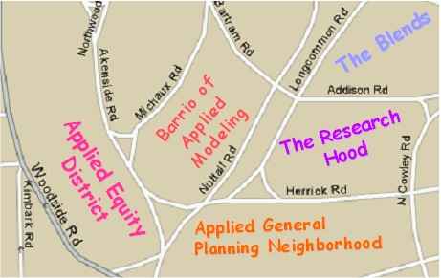

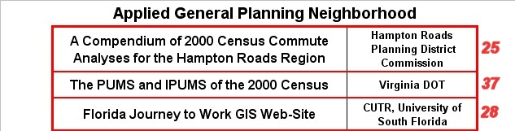

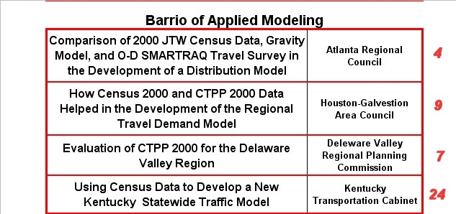

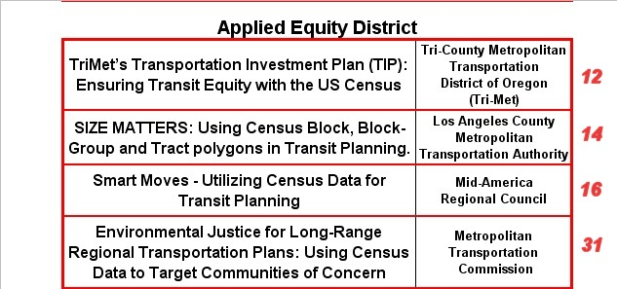

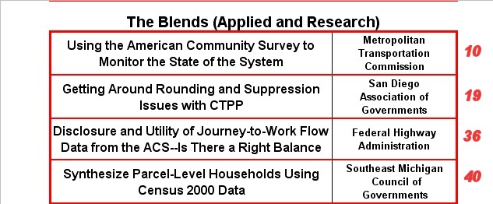
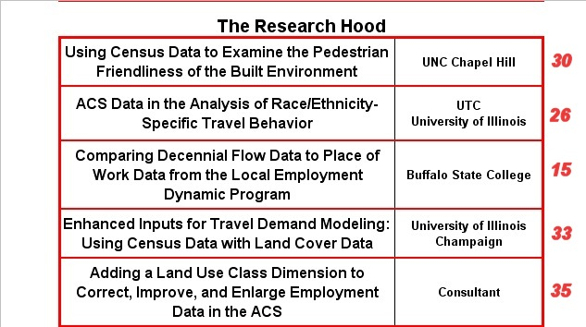

General Findings

Presented below are some general findings and observations that surfaced while reviewing the posters. These observations combine this author’s opinions with information found on each poster.

Initial observations:

CTPP flow data helps the regional planners understand the differences and variability between data sets and provides a "Reality Check” for other survey and modeled data (4).

CTPP and Census data are extremely useful for many of the travel demand model development steps but improvements dealing with rounding, thresholds, geocoding, etc., should be considered for 2010 (7).

Census and CTPP 2000 survey data played a vital role in this region’s travel model applications but there is a concern with deviations that occurred between the TAZs that were submitted and the final TAZs produced by the Census Bureau. There are also issues with the employment numbers or worker counts as well (9).

Has a working example of working with confidence Intervals and ACS data (10).

The US Census provides the data necessary to define areas that require transit assistance and to ensure transit equity throughout the total transit system (12).

While LEHD holds some intrigue there is still a great deal of research that could be done especially now that CTPP Part 3 data is available. The two sources should be checked against each other (15).

Census data was extremely helpful in identifying areas and characteristics of residents for the development of a major transit initiative (16).

Thresholds caused a loss of data but one can get around some of the suppression in Table 3-06 (means of transportation to work) by dividing table 3-14 (aggregate travel time by means of transportation to work) by table 3-08 (mean travel time by means of transportation to work) (19).

CTPP was useful in deriving regional travel characteristics for the development of the areas transportation plan (25).

Thumbs up on longitudinal data by county but thumbs down on TAZ coverage data (26).

Using Census data allowed this agency to identify EJ target communities and respond to them (31).

For CTPP 2000, rounding to 4 caused a systematic bias and undercount of workers while rounding to 5 would have been better (36).

Thresholds are bad, bad, bad (36).

Answered the question of when one should wait for the CTPP data or go ahead and use PUMS or IPUMS (37).

Makes a strong argument for the inclusion of employment land use classes in the ACS data (38).

General Findings:

Very few posters used just one data source or geographic summary level. Even the posters that used the CTPP or SF data exclusively drew upon a multitude of variables.

Of the 7 posters that used CTPP data exclusively, only two used just a single part.

More than half the posters dealt with understanding travel behavior and the motivators behind our behavior.

Descriptive analysis using small geographic units of analysis seem to be the norm rather than the exception.

Small area data is extremely useful to transit planning and equity analysis not only at the resident end (Part 1) but for the work trip flows (Part 3) as well.

The community of transportation users generally wants to help increase the utility of the Census data, specifically the ACS, while integrating more and more of it into their processes.

Conclusion

Overall the Posters and the Poster session met its goal of bringing the users together while stimulating them to discuss issues, show their work and help add to the success of the conference. Although not part of these proceedings the TRB committee on Urban Data and Information Systems hopes to provide a link to the location of the posters and any supporting material prepared by the authors on its committee web page (http://trb.mtc.ca.gov/urban/). A link will also be maintained from the committee’s Subcommittee on Census Data for Transportation Planning we page as well, http://www.TRBcensus.com/
Attachment 1: Ed’s Worksheet

